Sona-Systems Registration and Operation Guide: Participants

Introduction
You can access the system at any time, from any computer, with a standard web browser. Once you have set up your account, you can view a list of available studies and any restrictions, sign up for studies and track your progress throughout the semester. The system will track when you receive credits for a study, so you can view this online as well.

Getting Started
Go to: http://uco.sona-systems.com

Requesting an Account (SIGNING UP)

- Click the link “Request an Account” on the lower left-hand corner and fill out the form. YOU MUST USE YOUR UCO EMAIL ACCOUNT TO REGISTER.
- Click “Request Account” at bottom of the page.
- You will receive an email notification immediately with your login information including login instructions for the system.
- You will be emailed a default password, which you can change after your first login.
- You may provide an alternate email address (after your first login) if you
prefer to receive future notifications at another email address. The email will come from the administrator’s email address (listed on the request account page), so be sure to configure your junk mail filters to allow email from that address.

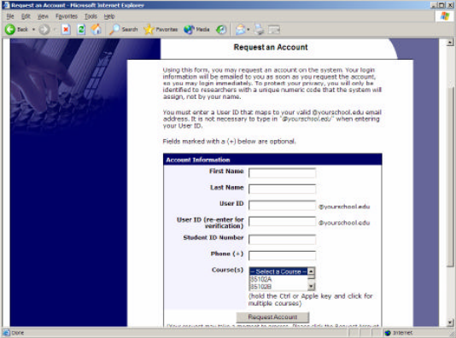
Figure 1 - Requesting an Account

Logging In
Once you have your login information, go to the front page of the site and enter your user ID (first part of your UCO email address) and password to login.
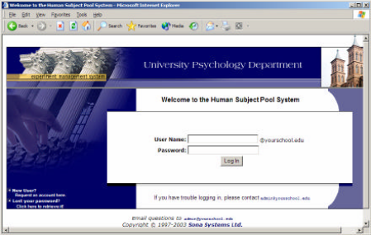
Figure 2 - Login Page
Once you login, you will be asked to review and acknowledge your organizations human subject policy for research. You will need to acknowledge this only once every 6 months. You will also be asked to participate in a pretest. After you complete these tasks, you will see the Main Menu.
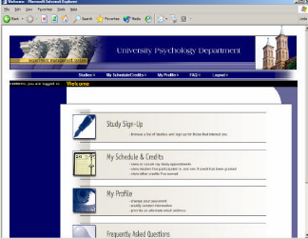
Figure 3 - Main Menu

Your login (also known as a session) will expire after a certain period of inactivity, usually 20 minutes. This is done for security purposes. If this happens, you can always log in again. When you are done using the system don’t forget to log out.
Retrieving a Lost Password
If you have forgotten your password, click on the section “Lost Your Password? Click here”, and the computer will send it to you. Do not email the Administrator.
Logging Out
When you are done using the system, choose Log Out from the toolbar at the top of the screen. You are now logged out. It is always a good security measure to close all your browser windows as well, especially if you are using a computer that is shared by others.
Changing Your Password and Other Information
If you would like to change your password or other information about yourself, choose “My Profile” from the top toolbar. If you would like to change your password, type your new password (twice, for confirmation) in the provided boxes.
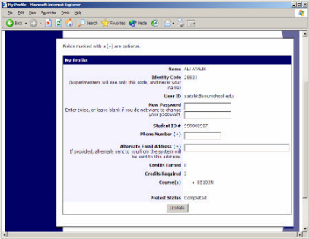
Figure 4 - Updating Your Profile

Email Address Options
There are certain events in the system which will cause an email notification to be sent to you. Most often, these are notifications that you have received credit for a study, or a confirmation that you have signed up for a study. Your email address is displayed to the researcher when they view who has signed up for their study, in the event they need to contact you. Be sure you keep your email address current.
Studies
You may view studies and sign up as needed. Be sure you meet any special requirements listed. You may cancel your appointment through the system as well. You may see some studies that are online only. You should read the details of these studies closely. Online studies must be completed at the time you sign-up.
Viewing Studies
To view a list of studies, click on Studies from top toolbar. You will see a list of studies. A brief description of each study will be listed, as well as any special requirements that may restrict your eligibility to participate in the study. If you do not meet the requirements then you will not be allowed to participate in the study.
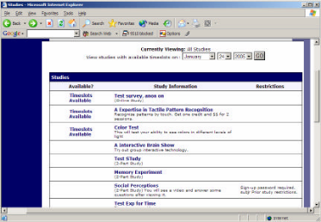

Figure 5 - Viewing Studies

Studies that currently have available participation times (timeslots/appointments) will have “TIMESLOTS AVAILABLE” listed next to the name of the study. If no studies have available timeslots, check back the next day to see if new timeslots have been added. You may also select a specific date to view studies with available timeslots on that date. To view more information about a study, click on the name of the study.
Two-Part Studies
Some studies are two-part studies, where you must sign up for both parts of the study at once, and the two parts must be scheduled a certain number of days apart. These studies will be clearly marked.
Online Survey Studies
Some studies may be online survey studies. If you sign up for one of these studies, you will be taken immediately to the survey. As soon as you complete the survey, you will receive credit. You may withdraw from the survey at any time. If you withdraw, you will not be granted credit.
Signing Up For Studies
Find the study you would like to participate in (see Viewing Studies in this documentation). Click on the study name for more information. Check the listing for special restrictions or eligibility requirements, as well as a contact person if you have questions about the study. Some restrictions are automatically enforced by the system. If the study has certain prerequisites or disqualifiers (studies you must not have participated in to participate in this study), those will be listed, as well as a note about whether you meet those eligibility requirements.
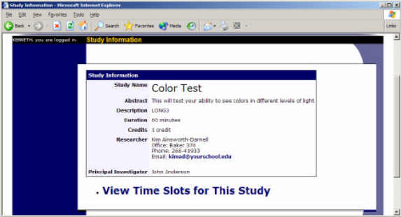

Figure 6 - Study Information

The study may have other restrictions listed as Subject Restrictions. An example of a Subject Restriction is “Left-handed people only.” If listed, then the system will still let you sign up but you should no do so as the researcher will not accept your participation once you arrive and could face a penalty.

Some studies require a special password to sign up. If this is the case, it will be noted. The researcher should have given you this special password. It is not the same as the password you use to login to the system. You will need to enter the special sign-up password just before you click the Sign Up button to sign up for a timeslot. You may only sign up for a timeslot up until a certain deadline before that appointment is scheduled to occur. The system will not show a Sign Up button for timeslots where it is too late to sign up.
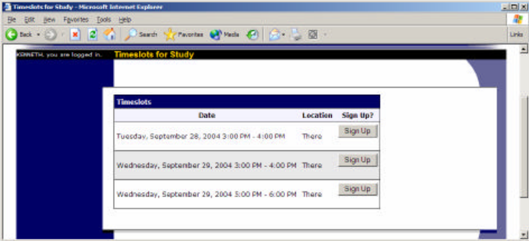

Figure 7 - Study Timeslots

Once you have determined you meet all the requirements, click on View Timeslots for this Study and you will see a list of available timeslots. Choose a timeslot that is convenient for you, and click Sign Up. Please note that researchers will not set up special times for you! You must either choose an available time slot or another study. After you click Sign Up, you will see information displayed confirming the time and location of the study you plan to participate in. You may receive an email confirmation as well, depending on how your system is configured. You are now signed up for the study. To cancel your sign- up, see Canceling a Sign- Up in this documentation.
Canceling a Sign-Up
- Go to the “My Schedule and Credits” page.
- Choose the My Schedule/Credits option from top toolbar.
- You will see a list of your scheduled and completed studies(see the Tracking Your Progress section of this documentation for more info).

Studies you are currently signed up for that you are allowed to cancel will have a “Cancel” button next to them. There is a time limit before the study is to occur, when it is too late to cancel. This restriction is listed at the bottom of the page.

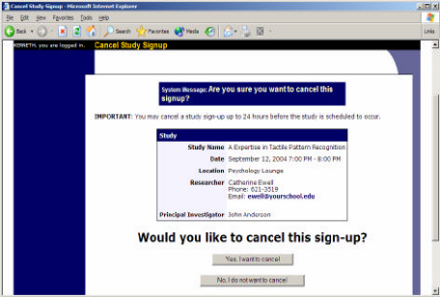
Figure 8 - Sign-Up Cancellation

Once you click Cancel to cancel your sign-up, you will see a confirmation page. You will also be warned if your cancellation might affect your ability to participate in other studies you have signed up for, due to pre-requisite restrictions. If the cancellation will affect your ability to participate in another study you are signed up for, it is your responsibility to deal with this issue (usually by canceling the additional study as well). The system
will warn you, but will not block the cancellation.
- Click Yes to cancel your sign- up and the sign- up will be cancelled immediately.
- If you cancel the first part of a two-part study, the second part will also be cancelled.
- If you cancel the second part of a two-part study, the first part will not be cancelled,
but you will need to ask the researcher to sign you up for the second part again, if you would like to participate in it at a later date.
Tracking Your Progress
You may track your progress at any time by choosing the “My Schedule/Credits” option from the top toolbar. When you view this page, you will see at the top a list of the number of credits you are required to earn, and how many you have earned so far. Below that, if you have signed up for any studies, those are listed as well. In the list of studies, you will see information about your credit status.

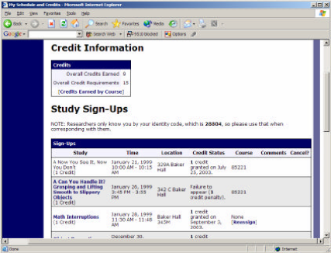
Figure 9 - Viewing Your Progress

If you failed to appear for a study, and did not cancel within the time allowed for cancellations you will be assessed a penalty.

Next to each credit or penalty, you can also see any comments the researcher left regarding the study and your credit for it. Non-study credit is also listed, when applicable. Non-study credit is usually granted for writing a paper or some other special situation previously arranged with your instructor.

